Adventure Work Power BI Report

**---------------------------------------------------------**

# Company

Adventure work is a large Multinational Company that Manufactures and sells Bikes Components, Accessories and Clothing. They sell their products in North America, Europe, Australia through online sales and wholesalers.

# Analyze the Dataset.

In the dataset folder, there are 7 tables that describe the nature of the company, and 3 tables contain sales data. Among the 7 tables, there are: calendar, customer, product categories,

product subcategories, products, returns, and territories. The sales dataset comprises 3 tables: 2015 sales, 2016 sales, and 2017 sales up to June 30th.

* Calendar Table: The Calendar table contains the date column.
* Customer Table: The Customer Table contains information about customers such as name, marital status, gender, annual income, number of children, qualification, and occupation.
* Product Categories: The Product Categories Table contains the names of product categories such as bikes, components, clothing, and accessories.
* Product Subcategories: The Product Subcategories Table contains subcategories of product categories. Each category, such as bikes, has multiple subcategories like mountain bikes, road bikes, and touring bikes.
* Product Table: The Product Table contains information about each product, including the product name, model name, description, colour, size, style, cost, and price.
* Return Table: The Return Table holds information about products returned by customers, including return date, return quantity, and product key.
* Territories Table: The Territories Table contains demographic locations where the company sells its products. Demographic categories include region, country, and continent.

Sales Tables: There are three sales tables for the years 2015, 2016, and 2017. Each table shows the sales for its respective year. The columns in these tables include order date, stock date, order quantity, and total sales, among others. It's important to note that the 2017 sales table only includes entries up to June 30th, accounting for 6 months of sales records. Therefore, the total sales for 2017 may be less than the total for 2016. However, this doesn't necessarily indicate poor performance by the company, as there are still 6 months remaining to achieve the sales targets.

# Database schema

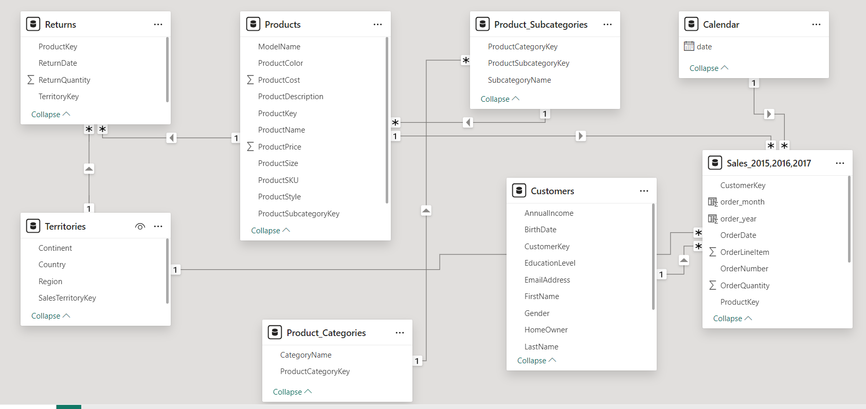

# Clean and Organize the Data

1. Load and transform all 7 tables (Territories, Products, Returns, Subcategories, Product Categories, Customers, Calendar), and import the 3 sales tables of 2015, 2016, and 2017.
2. In this data there is not any null value.
3. Change the data type of the order date and stock date columns in the 2015, 2016, and 2017 sales tables.
4. In the 2017 sales table, the order date contains two types of values: some use slashes

(/) and some use hyphens (-). Change the data type from date to text, replace slashes (/) with hyphens (-), and then change the data type back to date using locale.

1. Append all 3 sales tables into one table called "Sales 2015,2016,2017".
2. Create a "Total Sale Price" column: Sales 2015,2016,2017 **[Quantity] * Products[Price]**.
3. Create a order year and order month column in sales table using orderdate column.
4. Create a profit column by using Sales 2015,2016,2017 **[Quantity] *( Products[sellingPrice] – products[costprice])**

# Some Important Visualization

* + **Column Chart for Sales of Categories**: Create a column chart showing sales of three categories: bikes, accessories, and clothing. Each bar represents the sum of sales for all 3 years of a particular category. Customize the formatting by changing the colour of bars, x-axis text, y-axis text, and modify the chart title. Format the chart colours using a function, where higher values are displayed in darker colours and lower values in lighter colours. Add a divider under the title.
  + **Single-Bar Chart for Proportion of Sales by Year**: Create a bar chart with a single bar representing the proportion of sales for each year. Display the sales values under the bar. Customize the chart format to display 2015 sales in one colour, 2016 in another, and 2017 in a third colour.
  + **Donut Chart for Sales by Profession**: Create a donut chart showing the sum of sales for all years by profession. Each slice of the chart represents a different profession of customer. There are 5 distinct customer professions. Customize the chart format, modify the title, and change the colours of the slices to match the dashboard.
  + **Funnel Chart of Top 10 Products:** Create a funnel chart to display the top 10 products by sales. Each bar in the funnel chart represents a product and its proportion of sales among the top 10 products. The size of each bar decreases with decreasing sales amount. Customize the chart format, including the colours of the bars to match the dashboard colour theme. Apply a function to the bar colours so that higher value bars appear darker and lower value bars appear lighter. Provide an appropriate title for the chart and change the colour of the title. Add a border line under the title

# Slicers

*Slicer is used to filter the data and make dashboard interactive.*

* + First slicer displays a date range, allowing analysts to view data within a specific year range. This slicer uses the date column from 2015 to 2017.
  + The second slicer shows distinct countries, enabling analysts to view data from a specific country or a combination of two or more countries. There are 6 distinct countries available: Australia, Canada, France, Germany, United Kingdom, and United States.
  + The third slicer displays continent .

# Formatting of Dashboard

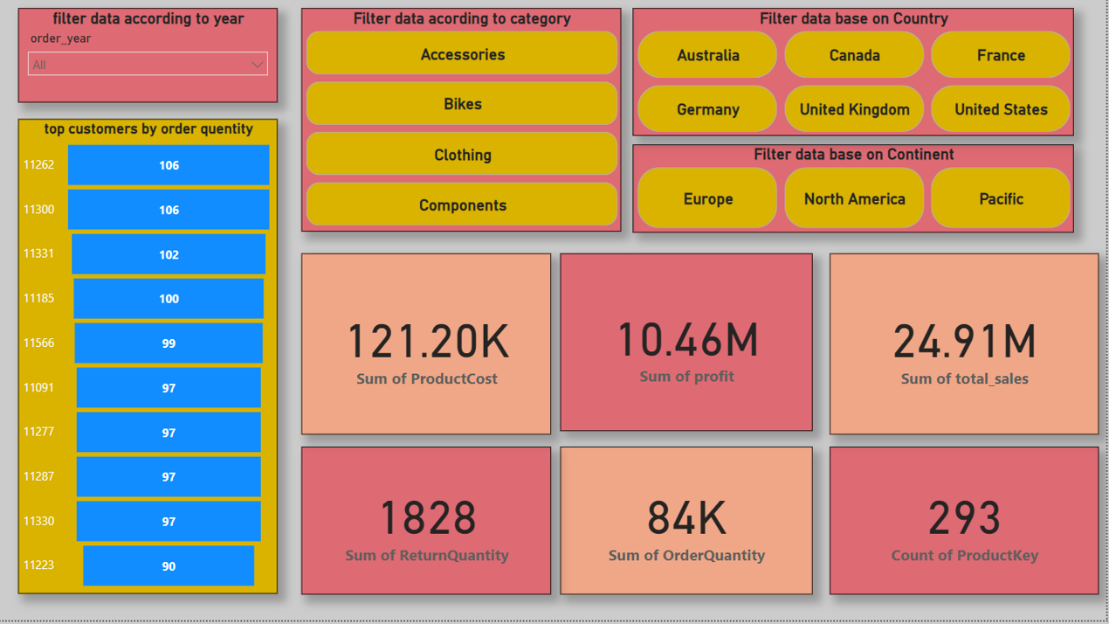

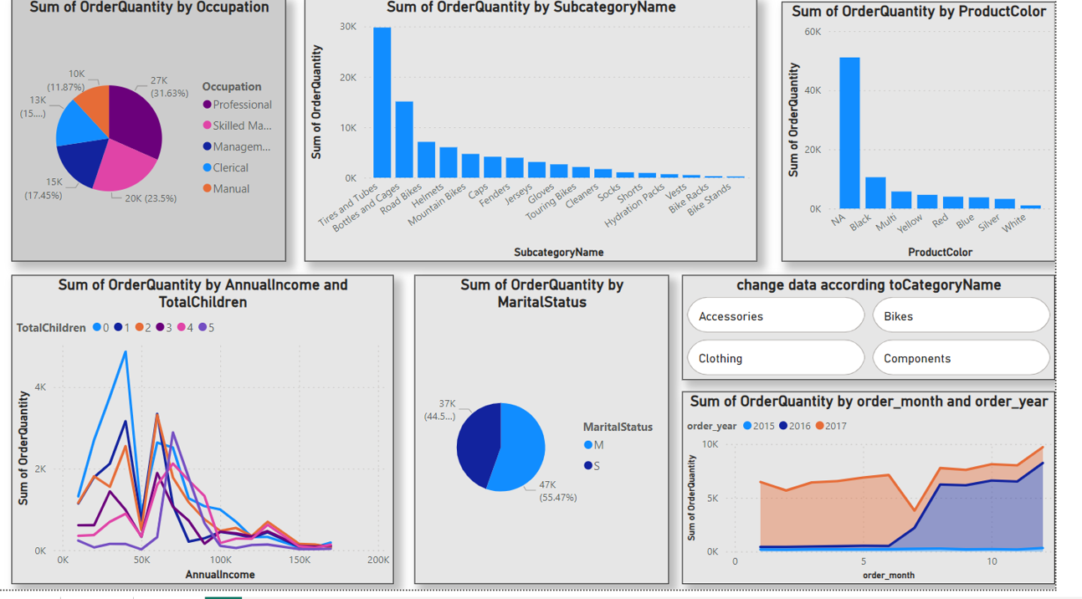

# 

# Insights

* + Most of the sales are made by bikes, with very few coming from accessories and clothing.
  + Most of sales come from the United States ($7.94 million), followed by Australia ($7.42 million).
  + The company has shown consistent growth year by year. Sales in 2015 were $64 million, in 2016 they were $93 million, and as of June 2017 (in just 6 months), the company's
  + sales reached $91 million. Most of the sales come from customers in professional occupations. However, this varies by country. In France, most sales come from manual workers, while in Germany and the United Kingdom, most sales come from clerical workers.
  + The top-selling product of the company is the Mountain-200 Bike ($7.17 million), followed by the Road-250 Bike ($4.20 million).
  + The total sales for 2.5 years (from 2015 to June 2017) amount to $24.91 million
  + Canada has performed exceptionally well among all the countries. Sales until June 2017 are 16% higher than the overall sales in 2016. This means that Canada has generated more profit in 6 months than it did in the entire year of 2016. Sales in Canada for 2016 were $5.2 million, while sales until June 2016 amount to $6.38 million.

# Actions to be Taken.

* Clothing generates no revenue, so we may need to improve clothing sales or consider shutting down this category.
* Mountain and road bikes have higher sales compared to others. People love these types of bikes, so we can launch more models of them.
* Customers return accessories more frequently than bikes and clothing. We need to improve the quality of accessories.
* Canada could be a promising market. We should focus more on this region and increase advertising in Canada.